INVITATION

6th siBIM Conference:
siBIM 2020 – STRUCTURED DATA ARE NEW GOLD
3. and 4. 11. 2020, online
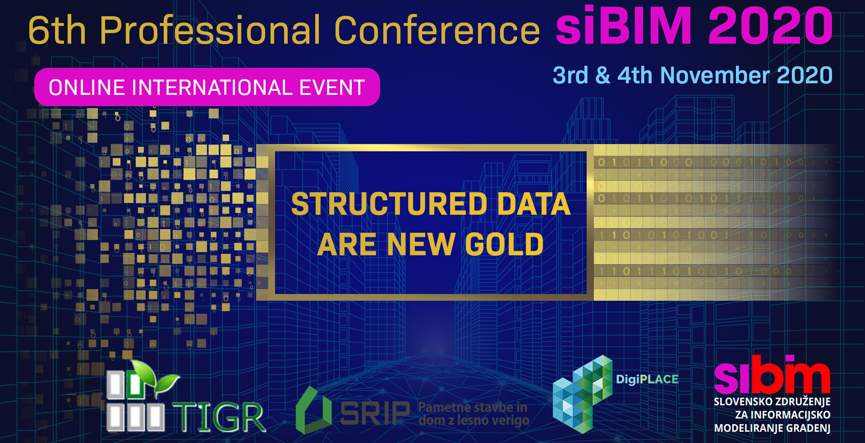

The siBIM Association is organizing the sixth conference on 3rd and 4th November 2020, this time with the subtitle "Structured Data are New Gold". The conference will take place online as a two-day event. The conference is organized in cooperation with the DigiPLACE project and the Institute for Sustainable and Innovative Construction ZTIGR.
The topics of this year's conference will focus on various aspects of data implementation in BIM processes with presentations of interesting domestic and foreign projects.
Conference Program
DAY ONE (3. 11. 2020)

TIME LECTURES

09:00 09:10 OPENING OF DAY 1

09:10 09:30 Sebastjan Meža:
BIM AND THE CIRCULAR CONSTRUCTION

09:30 09:50 Veljko Janjić:
NEXT GENERATION OF DIGITAL CONSTRUCTION MANAGEMENT

09:50 10:10 Štefan Jaud:
IFC DEVELOPMENT FOR INFRASTRUCTURE PROJECTS

10:10 10:30 Matjaž Šajn:
buildingSMART CHAPTER SLOVENIJA

10:30 10:40 Q&A

10:40 10:50 BREAK

10:50 11:10 Žiga Turk:
PLATFORMS – THE FUTURE ECOSYSTEM FOR CONSTRUCTION

11:10 11:30 Nicolas Naville:
TOWARDS A EUROPEAN REFERENCE ARCHITECTURE FOR PLATFORMS

11:30 11:50 Bart Ingelaer:
DIGITALIZATION OF EUROPEAN CONSTRUCTION: CURRENT STATE, FUTURE SCENARIOS AND BARRIERS IN BETWEEN

11:50 … DISCUSSION

12:30 CLOSING OF DAY 1

DAY 2 (4. 11. 2020)

TIME LECTURES

09:00 09:10 OPENING OF DAY 2

09:10 09:30 AWARD CEREMONY OF HONORARY MEMBERSHIPS

09:30 09:50 Christian Donath:
PRODUCT PLACEMENT 4.0 - CHANCES OF DIGITALIZATION FOR PRODUCT MANUFACTURERS

09:50 10:10 Jakub Sandak:
INTEGRATING SERVICE LIFE SIMULATIONS OF BUILDING FACADES WITH BIM TO REDUCE ECONOMIC AND ENVIRONMENTAL IMPACTS

10:10 10:30 Mojca Rebec Fučka:
DIGITAL PLANNING - BIM IN THE LIGHTING INDUSTRY, EXAMPLE OF INTRA LIGHTING

10:30 10:40 Q&A

10:40 10:50 BREAK

10:50 11:10 Damjan Bradač:
BIM IN ARCHITECTURE AS A PLATFORM FOR COLLABORATION IN BETWEEN VARIOUS DISCIPLINES

11:10 11:30 Matic Kotnik:
DEVELOPMENT OF STANDARDS FOR DIGITALIZATION OF PROCEDURES FOR MORE EFFICIENCY IN BUILDING ENVIRONMENT PROCESSES

11:30 11:50 Tomaž Petek:
GEODETIC DATA AND ONLINE SERVICES ON BUILDINGS AND CIVIL ENGINEERING OBJECTS

11:50 … DISCUSSION

12:00 CLOSING OF DAY 2

The organizer reserves the right to make minor changes or additions to the program.
Registration Fee
- Registration fee is 20 EUR. Participation is free for siBIM members (with paid membership fee for the current year).
Registration for the conference
Registration for the conference can be made on this link
When registering, please specify:
- name and surname of the participant
- IZS identification number (optional for Slovenian participants)
- the method of payment of the registration fee and the name of the legal entity, in case the legal entity pays.

For Slovenian participants: At Chamber of Engineers, we will propose that certified and supervising engineers and architects obtain credit points for participation in the conference in accordance with the General Act on Continuing Vocational Training of Certified Engineers.

Sponsorship Packages
We have prepared sponsorship packages
We invite companies to sponsor the conference and thus contribute to its success and impact.
Organizers

siBIM 2020 Organizing and Program Committee

